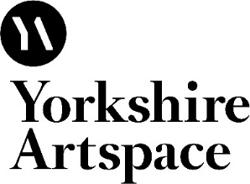

Starter Studio Application Pack: Ceramics

To apply for the 2017-2019 programme (starting early Oct 2017 ending late Sep 2019) please read the following information and complete the application form.

To foster new talent and support early career artists, Yorkshire Artspace runs two Starter Studio Programmes: one for Designer Silversmiths & Jewellers and one for Ceramicists in Sheffield.
Designed to help ambitious and entrepreneurial artists at an early career stage to develop their skills and creative enterprises in a supportive environment, the programmes offer access to shared workspace and equipment, technical and mentor support, business advice and occasional commission and exhibition opportunities.
The Starter Studio Programme for Ceramists is delivered from a large purpose built, eco-designed shared space at Manor Oaks Studios. If you work with clay and you are looking to further your skills and professional development, this may well be the opportunity you are looking for.
We are able to provide support for two ceramicists each year.
Key Features of the 2 year Programme include:
• 7am - 9pm access (although 24/7 access can be arranged with notification) to shared, equipped studio space
• Access to technical and mentor support
• Business advice and support
• Bursary to undertake online professional development training via The Design Trust
• Exhibition and residency opportunities
• Commission opportunities including the Northern Industrial Ceramic Commission
• Cost £120 per month (inclusive of heat/power) plus 1 month bond repayable on leaving the programme
• Receive a 20% discount on regular studio rental for 2 years from completion of the programme (subject to studio availability)

"This programme has been wonderful for me so far. If I look back a year when I worked from a garage in my hometown in Wales, trying to develop new work in freezing conditions with no support whatsoever, I wouldn't been able to imagine how quickly things can turn round with the right conditions and the best business and mentor support I could have wished for. In October 2014 I will be showing my new work at The Great Northern Contemporary Craft Fair. My confidence has greatly improved, my knowledge of the sector has increased and I have tons of ideas to get going on with. One of the best decisions made in the last year!" Sally Bertram

The mentors for the Programme are experienced, nationally known ceramicists, including Penny Withers, Hanne Westergaard, Pottery West, Emilie Taylor, Anna-Mercedes Wear and Brian Holland.
Sheffield is a friendly and lively city with a population of approx. 700,000. Located on the boundary of the stunning Peak District National Park, Sheffield has great transport links (approx. 2 hours to London and approx 1 hour to Manchester, Birmingham, Nottingham and Leeds by train). It is claimed that Sheffield has more artists than any other city in England apart from London and this is reflected in the number of studio groups in the city. Sheffield is a great place to get your creative career started and we are happy to help you find your way around if you are new to the city.
Visit Our Favourite Places for more info: www.ourfaveplaces.co.uk

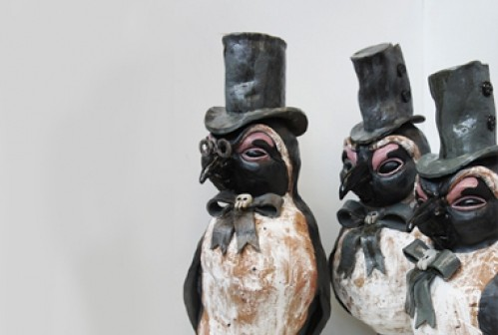
Previous Beneficiaries include;
- Megan Downs
- Hannah Staniforth
- Victoria Dawes
- Mike Scown
- Joanne Barlow
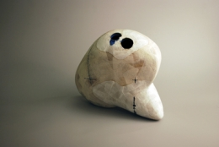
- Sally Betram
- Anne Laycock
- Bryony Penman
- Fay Jenkinson
- Jenny Lee
- Joel Neild
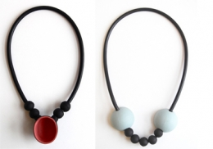
- Miles Gavin

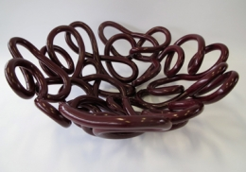

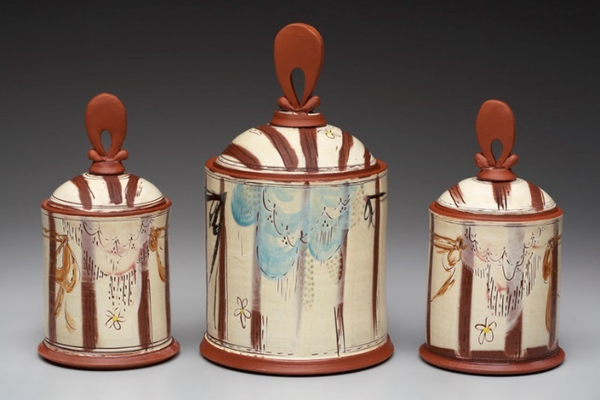

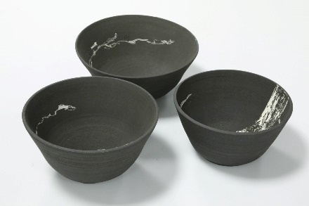

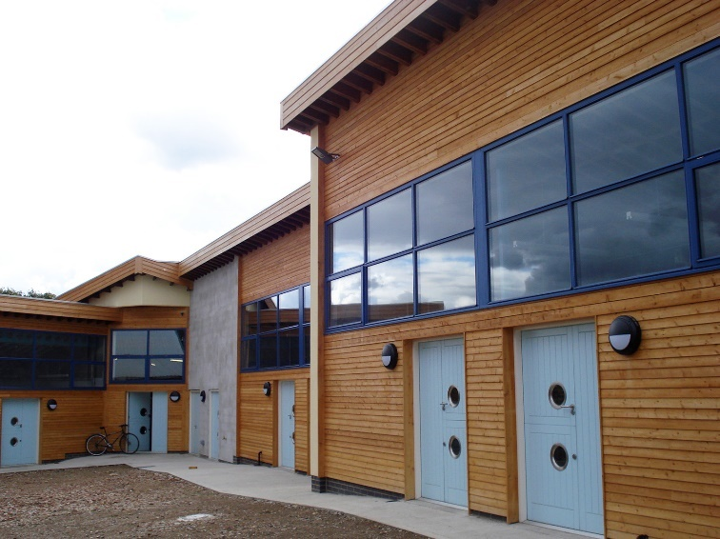

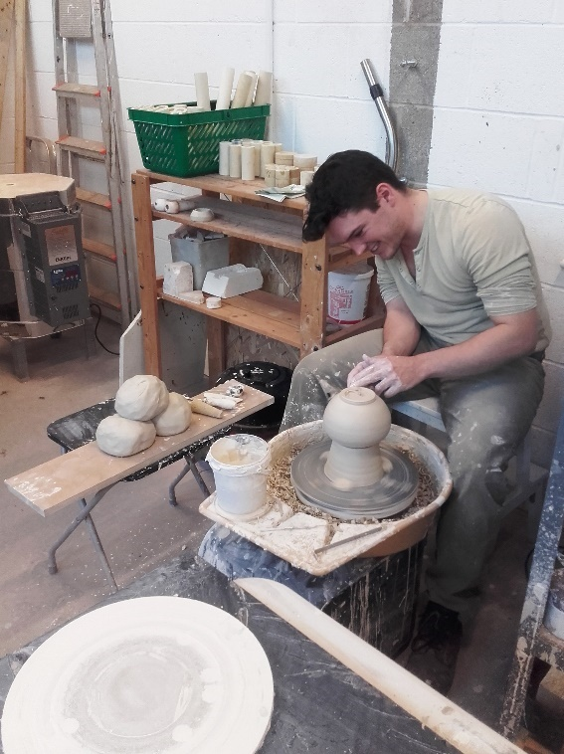

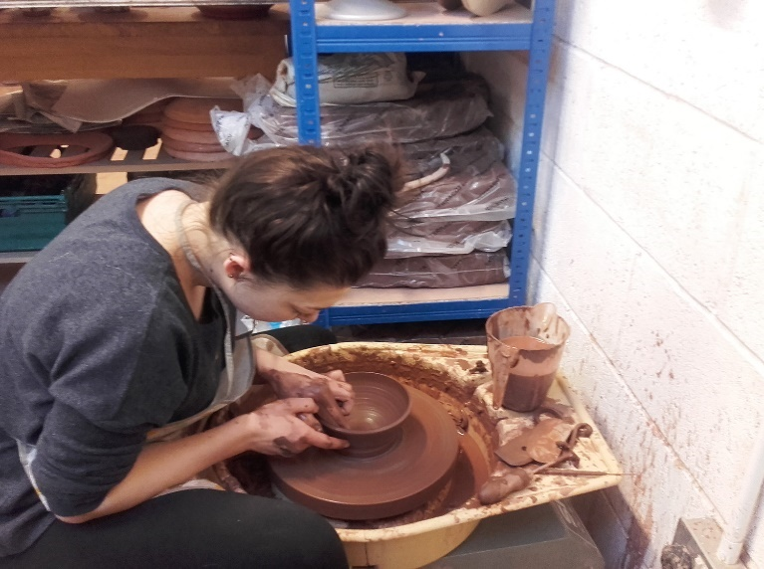

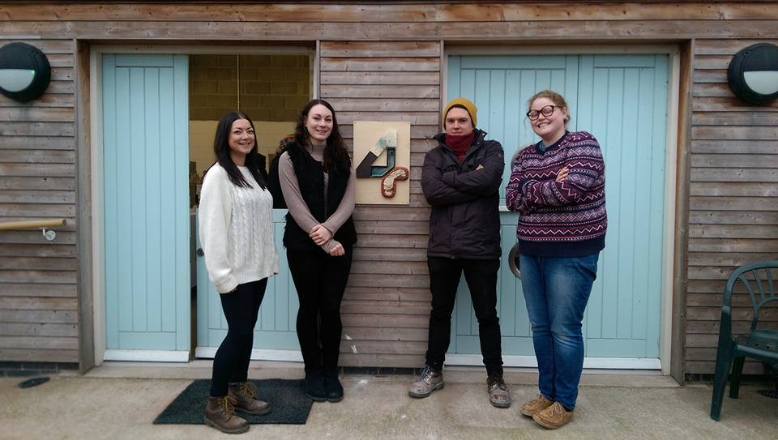

Application Form
- Contact Details
Name
Address

Mobile No.
Home Telephone No.
Email
Website
Please provide a brief description of your work and ideas:
(additional information may be provided on a separate sheet)

2. Visual Documentation Please email up to 10 images contained within a PDF document to illustrate your work. Please ensure the document does not exceed 8MB.
Please ensure each image is clearly labelled as follows: name of work, year made, materials and techniques used and size. Please provide any relevant image credit.

- Relevant Achievements
Please give a summary of relevant and recent achievements including educational qualifications, relevant work experience, workshops/projects attended, commissions, exhibitions and awards. Please continue on separate sheet if necessary.

- Ambitions & Targets
What are your long term ambitions and what do you hope to achieve during your time on the Starter Studio Programme? We will assess whether you are realistic with your ambitions. Please continue on a separate sheet if necessary.

- You and the Programme
How will you use the Starter Studio Programme to achieve your ambitions and targets? We will assess whether we are able to give you the support you need. Please continue on separate sheet if necessary.

- Referees
Please provide us with names and contact details of two referees. If you are a new graduate, one referee must be a former tutor.
1.

2.

- Equal Opportunities Form
Please complete the attached Equal Opportunities form.

Application Process
We accept applications throughout the year. Applications will be considered as they are received and places offered accordingly.
There is an overall cut-off deadline of 10th April for the Starter Studio Programme commencing in the respective October. However please note that all available places may have been offered prior to this deadline, so please do not delay in registering your interest and submitting an application.
The usual process is that following application you will be invited to attend an interview; a chance to meet face to face, show examples of your work and ask questions. Interviews can be arranged throughout the year until May, for the Programme commencing in the respective October.

How to Apply
To apply for the 2017-2019 programme (starting early Oct 2017 ending late Sep 2019) please send the above information (points 1-7) and optional additional information (CV, publicity material, artist statement) to Rachael Dodd, Programme Manager via email to rachael@artspace.org.uk
We strongly recommend that you visit our facilities before submitting an application. The Starter Studio Open Day takes place during our annual Open Studios event in November (full details, dates and times on our website) and we advise applicants use the opportunity to explore our facilities, chat with studio holders and ask any questions.
Please contact Rachael Dodd, Programme Manager at Yorkshire Artspace with any queries, on 0114 2130111 or rachael@artspace.org.uk

Equal Opportunities Monitoring Form
Completing this form is optional but doing so will help us meet our commitment to equality of opportunity. The form will be detached as soon as we receive it and filed anonymously. This information will not be shared with third parties.
Which best describes your racial or cultural origins?
Caribbean |  | African |  | Arabic
Indian |  | Pakistani |  | Bangladeshi
Chinese |  | Latin American |  | Irish
British or European |  | Other

Are you: Male Female
65+
55-64
45-54
35-44
25-34
19-24
0-18
Age:

Do you consider yourself to have a disability: Yes No

If Yes, what are your individual needs/requirements? (these can be discussed at interview)

Are you currently in paid work? (inc self-employment): Yes No
Is there anything else related to equal opportunities that you think we should know about?

Explanatory Notes:-
Yorkshire Artspace Society is committed to eliminating discrimination on the grounds of racial group, origin or nationality, sex, disability, religion or age. In accordance with the Disabled Persons (Employment) Act, Sex Discrimination Act, Race Relations Act and the relevant codes of practice, we are carrying out equal opportunities monitoring. This will help us to develop positive action strategies to overcome discrimination. The form will be detached from your application form and will not be used to make decisions about your application for residency, membership, studio space, commissions, workshops or other opportunities. The information will be collated for monitoring purposes and the form will be destroyed. No individual can be identified from this form.

